Chapter 8 Machines
extra worksheet 1: Leonardo da Vinci
Science as a human endeavour Verbal/linguistic
Name: Class: Date:
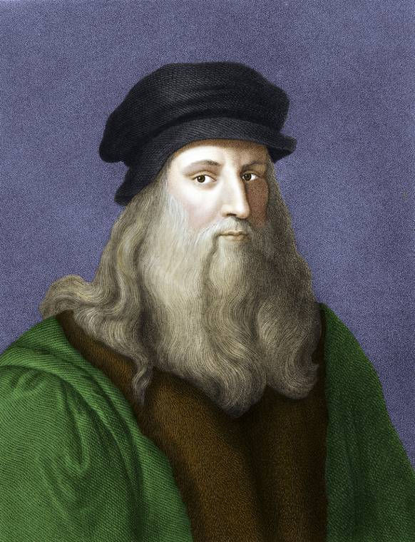
Leonardo da Vinci was born in Vinci, Italy, in 1452. He was a brilliant painter—the Mona Lisa and The Last Supper are two of his works. It was not until centuries after his death in 1519 that people realised how many technological designs he had created.
Leonardo da Vinci examined the structure of the heart by dissecting the bodies of oxen and about 30 human subjects. He discovered that the heart has four chambers, when at the time it was only believed to have two. Many of his observations and designs were recorded in back-to-front mirror writing in his notebooks because he tried to disguise his ideas from others.
Leonardo embarked on a quest for knowledge in a wide range of areas, including geology, optics, acoustics, music, botany, hydraulics, anatomy and naval armaments. He was said to be handsome, generous and charming, but also unreliable and vain. He stood out in a crowd as he liked to dress in bright, striking clothing while other men wore long, dark-coloured robes.
His designs for inventions included a self propelling car (shown below), a crane for emptying ditches, a snorkel for breathing under water, a therapeutic armchair, folding furniture, a type of armoured tank, a bicycle, spinning and weaving machines, various weapons, and even a robot with limbs that could be moved by a series of cables and pulleys. He designed a range of wonderful but unsuccessful flying machines. Some resembled large butterflies with four wings and included pedals, stirrups, harnesses, steering cables and standing platforms. One of his designs could take off vertically and was powered by a rotating blade—it was perhaps the first helicopter ever imagined. The designs he imagined were ahead of his time and are evidence of a great genius.
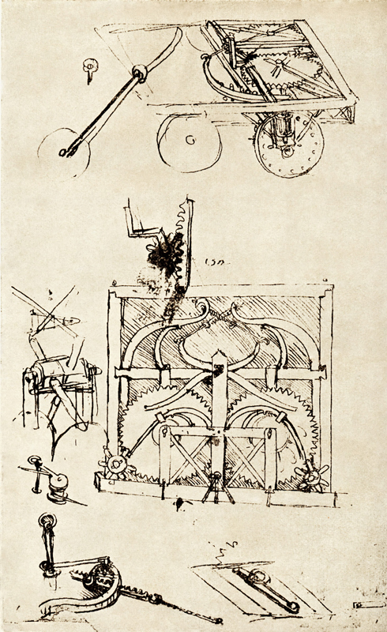
This self propelling car was just one of Leonardo’s designs. He planned for a series of gears and leaf springs to power its motion.
1 Recall when and where was Leonardo born.

2 State what he was most famous for immediately after his death.

3 a Explain what was unusual about the way Leonardo recorded his ideas in his notebooks.

b Propose a reason why he may have done this.

4 a Name three of Leonardo’s designs.

b Explain why people often comment that Leonardo da Vinci was ahead of his time.

5 a Propose why the desire to fly has fascinated people for so long.

b Recall the flying machine that is used today that is similar to a sketch made by da Vinci.

6 Imagine that you are Leonardo da Vinci, alive and well in Australia today. Construct a sketch of an invention that you think may be in use by the end of your lifetime.

